**A PROJECT REPORT ON**

**“YOUR VOICE – YOUR CHOICE”**

**Submitted by**

**VAISHNAVI R.**

**Under the Guidance of:**

**Mrs. Sandhyarani T.R.**

MCA

Lecturer

Dept. Of Computer Science,

Government First Grade College

Thirthahalli-577432

**2019-20**

**A PROJECT SUBMITTED TO THE DEPARTMENT OF COMPUTER SCIENCE,**

**GOVERNMENT FIRST GRADE COLLEGE THIRTHAHALLI, KUVEMPU UNIVERSITY,**

**IN PARTIAL FULFILLMENT OF U.G. DEGREE-BACHELOR OF SCIENCE**

KUVEMPU UNIVERSITY

**MARCH/APRIL-2020**

**WELCOME PAGE:**

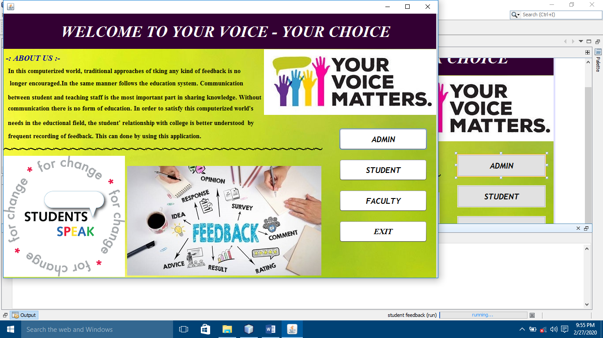

**STUDENT REGISTRATION FORM:**

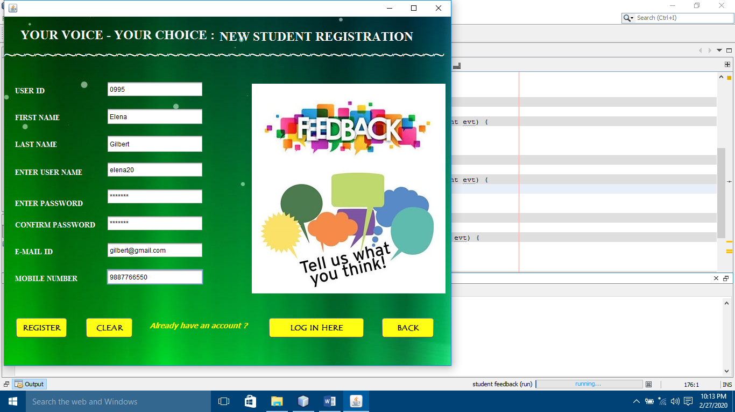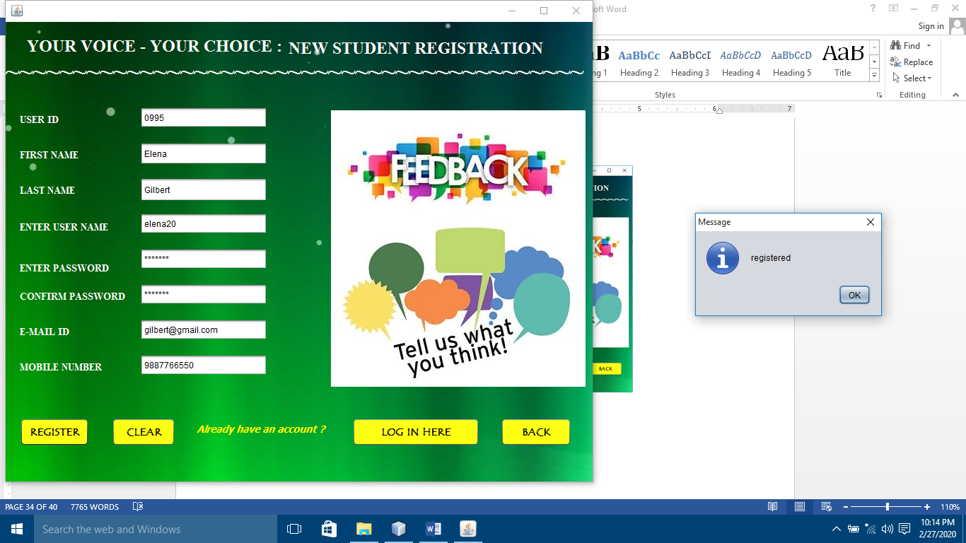

**STUDENT LOGIN FORM:**

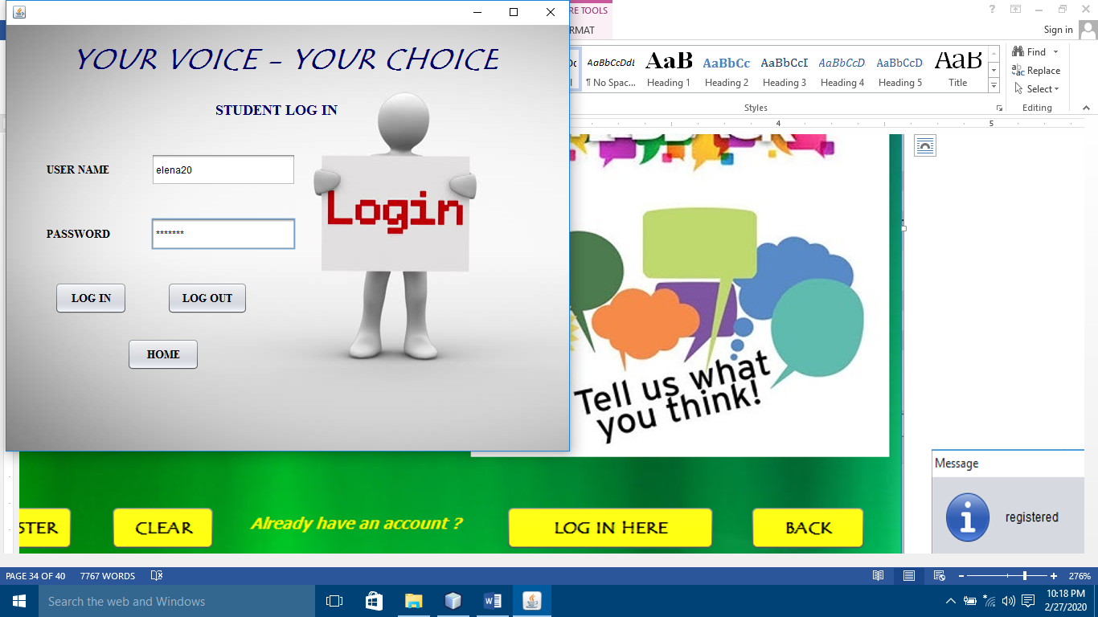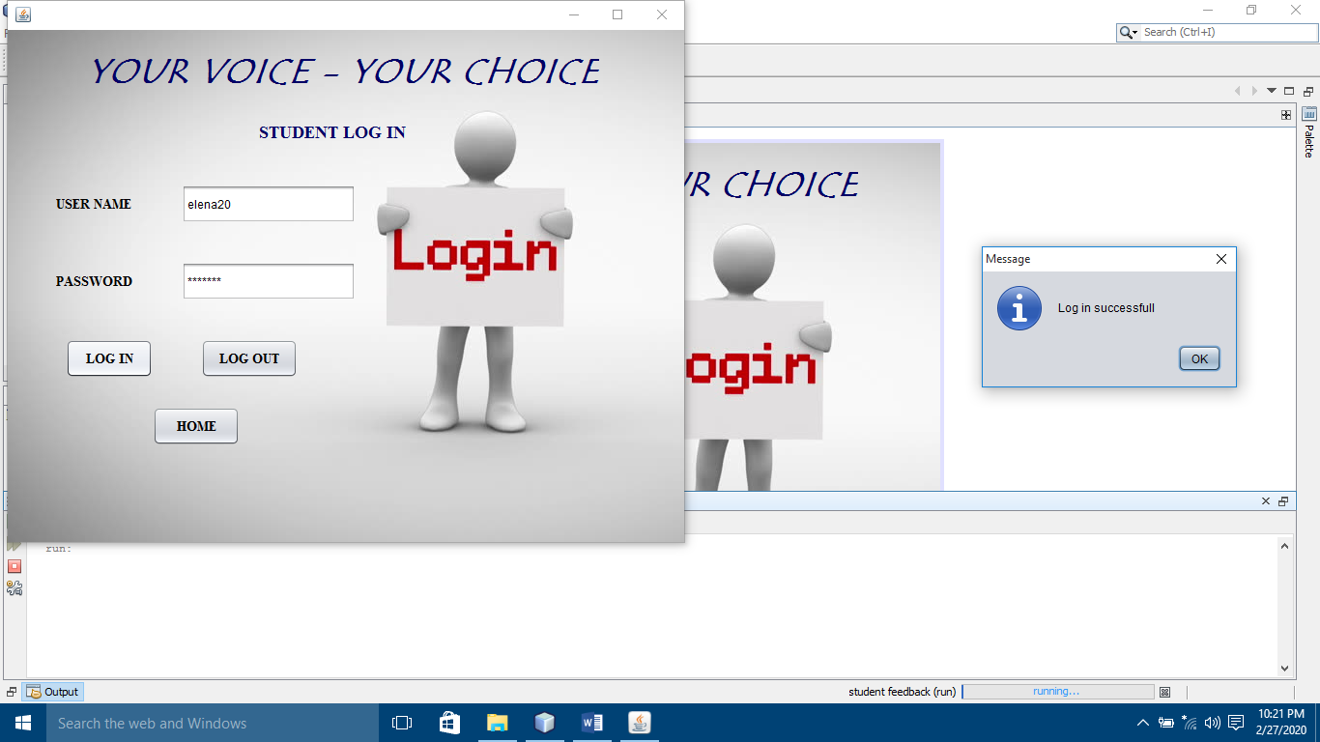

**TYPES OF FEEDBACK:**

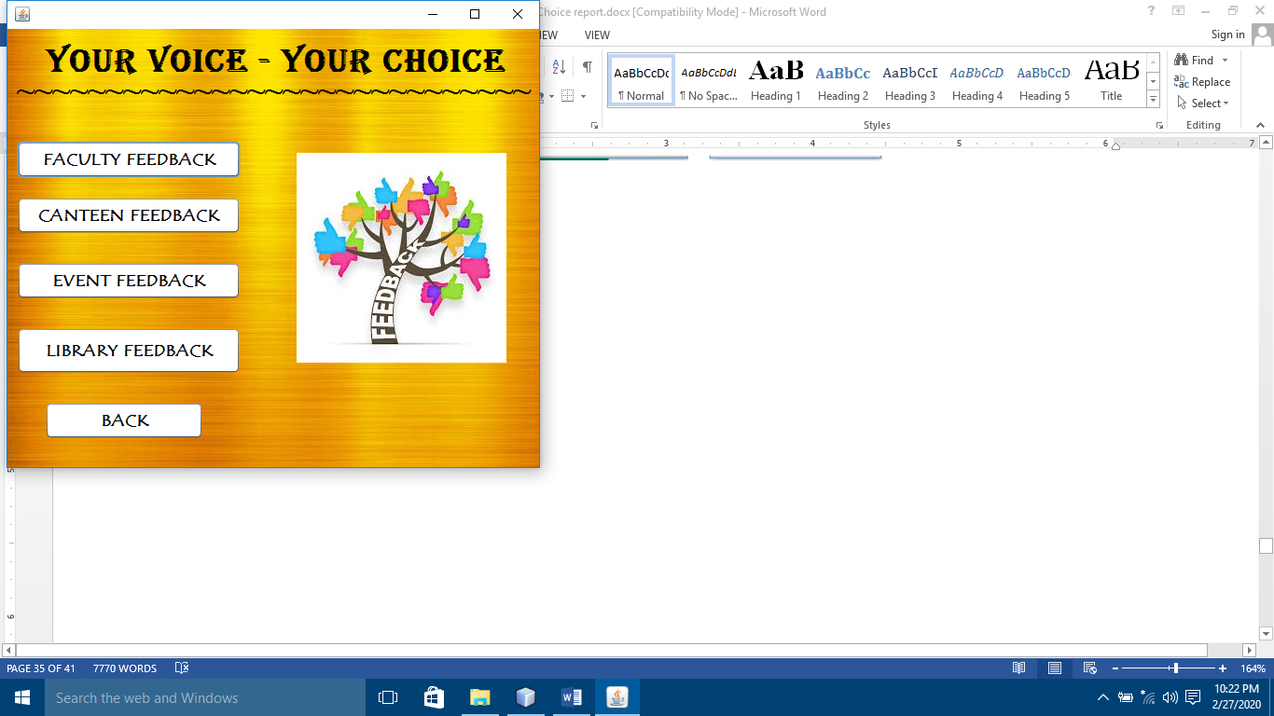

**FACULTY FEEDBACK FORM:**

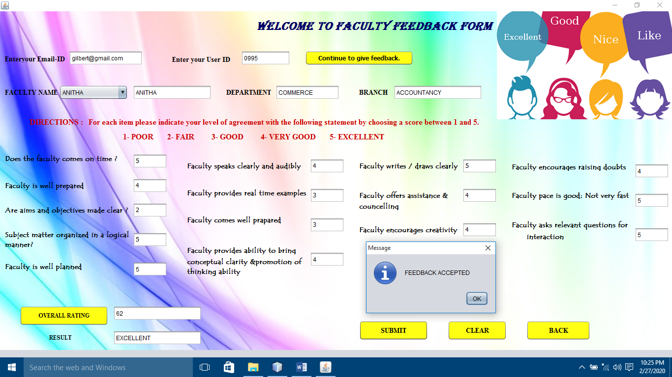

**CANTEEN FEEDBACK FORM:**

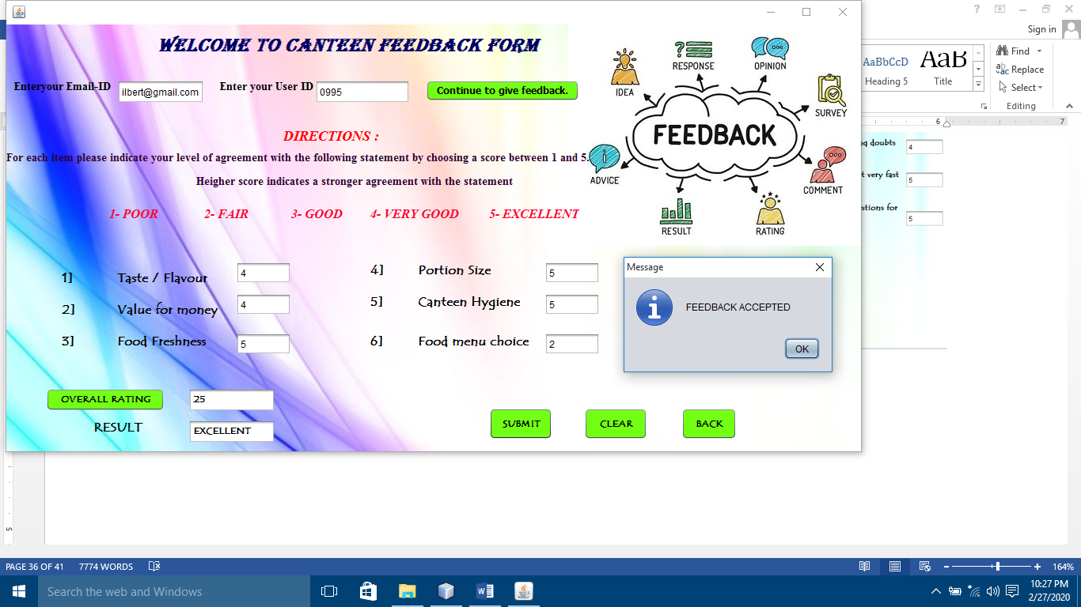

**EVENT FEEDBACK FORM:**

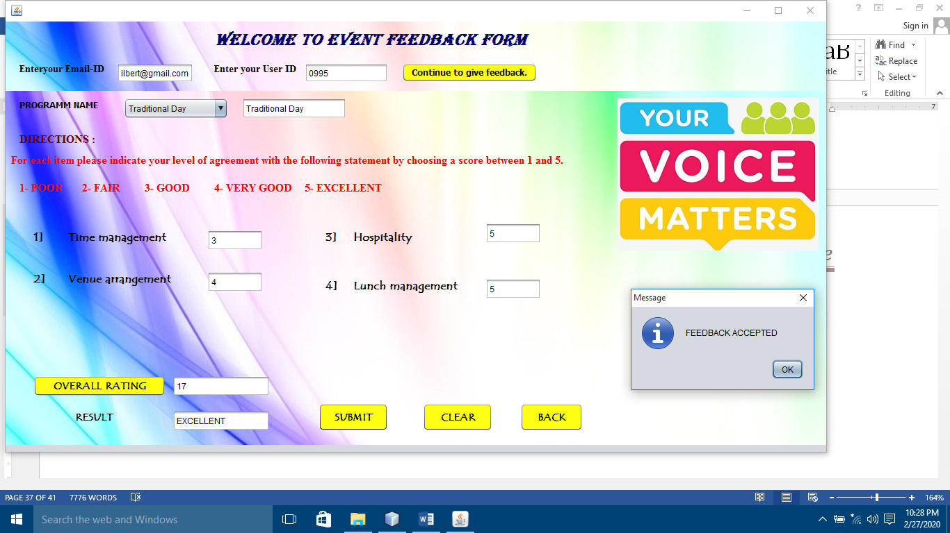

**LIBRARY FEEDBACK FORM:**

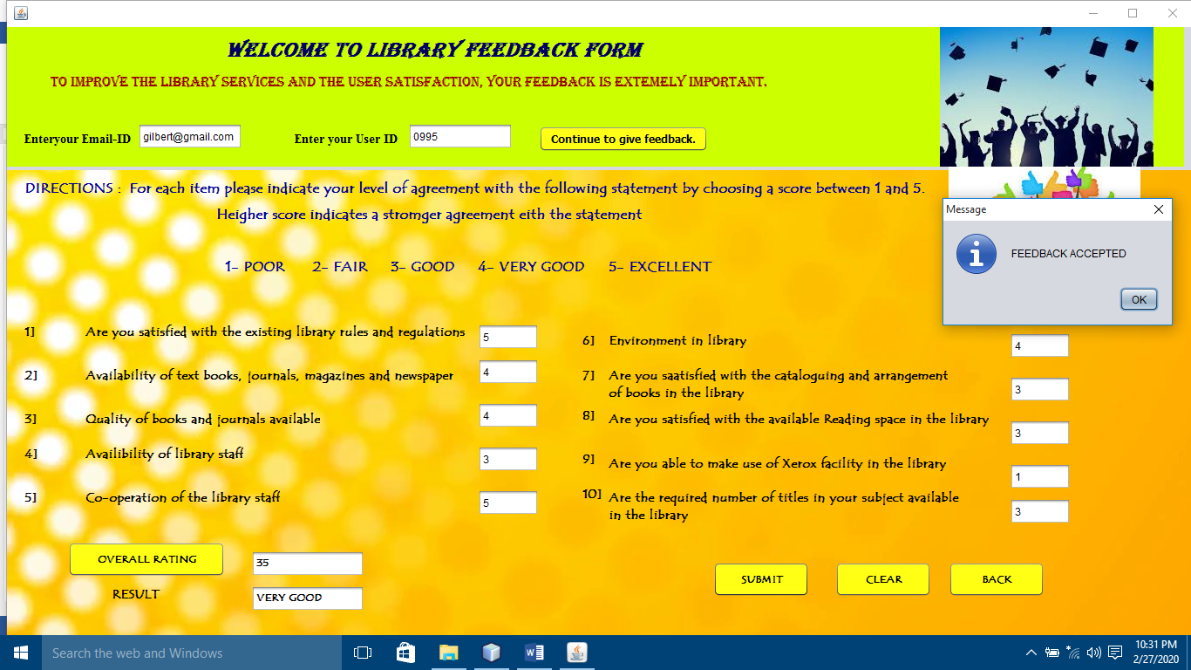

**ADMIN LOGIN FORM:**

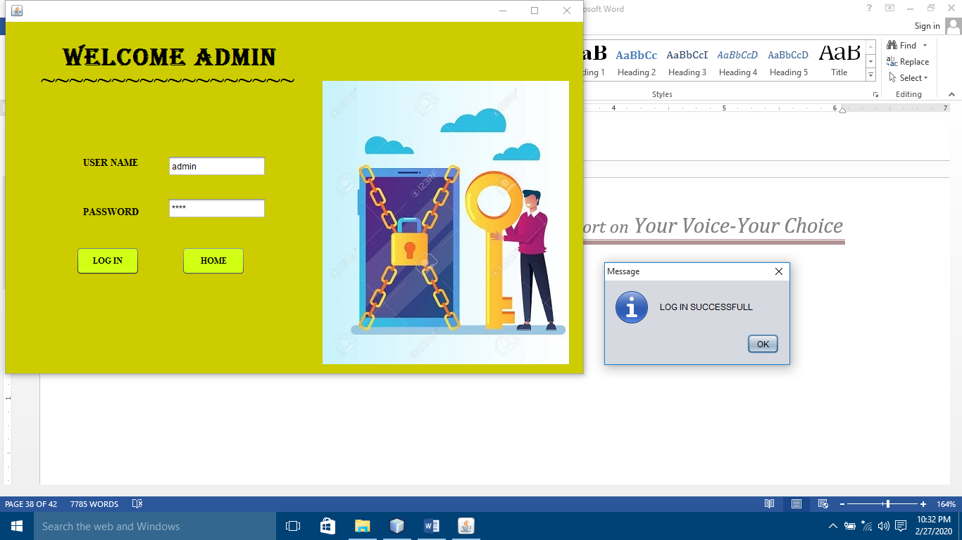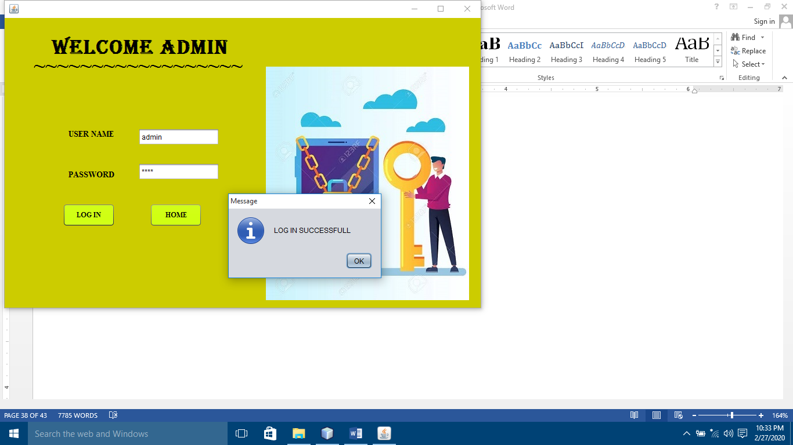

**ADMIN PAGE:**

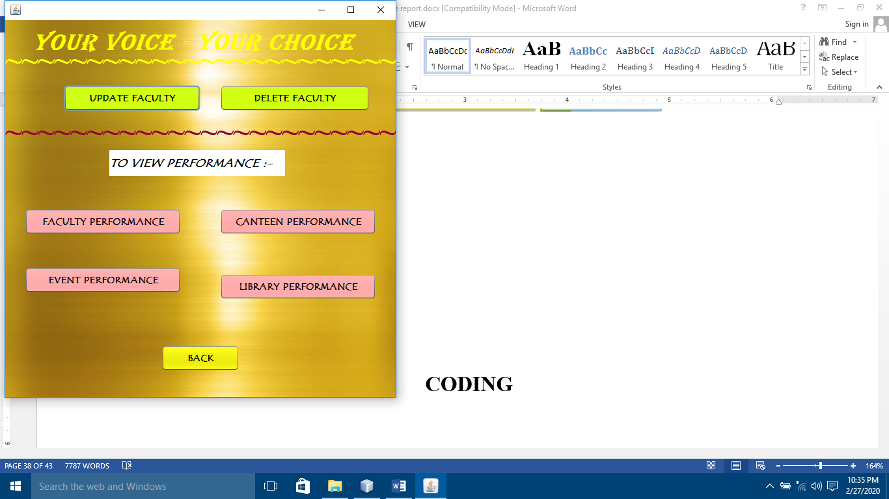

**UPDATE FACULTY:**

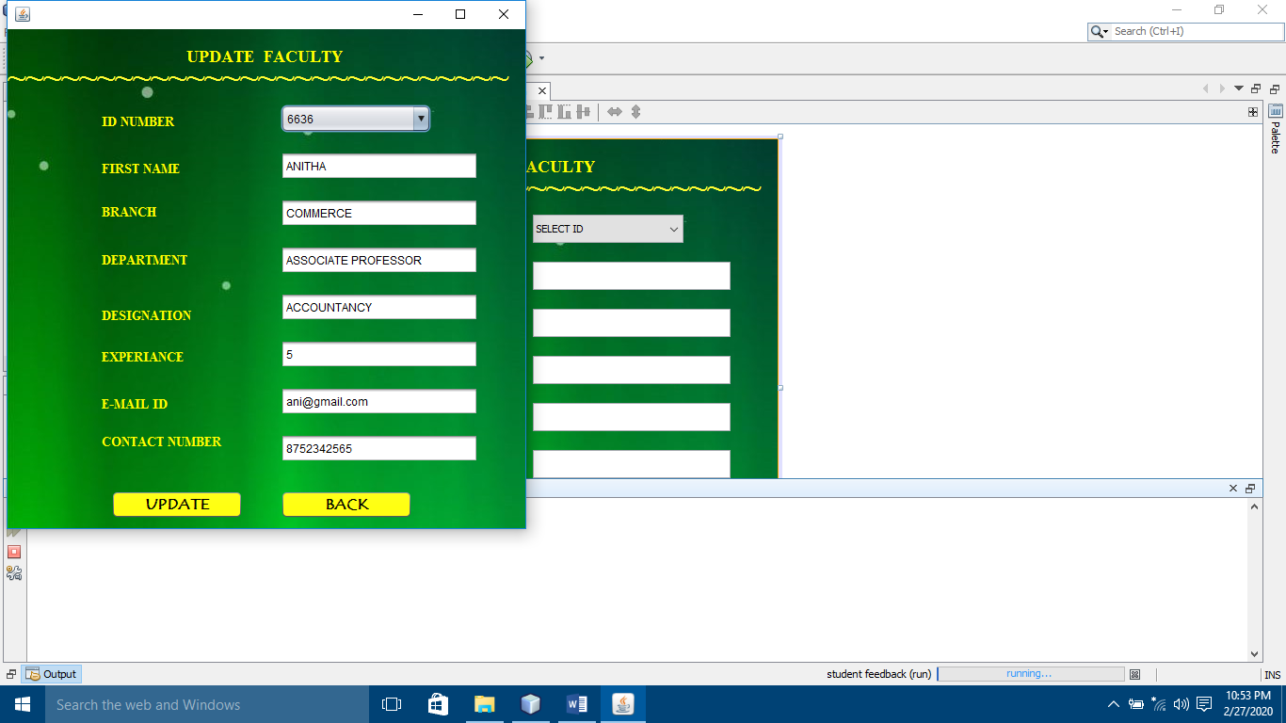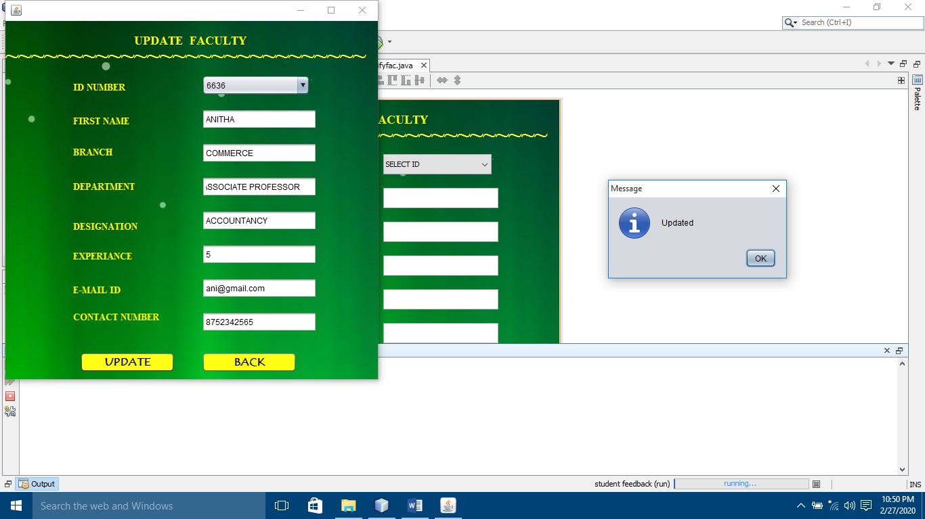

**DELETE FACULTY:**

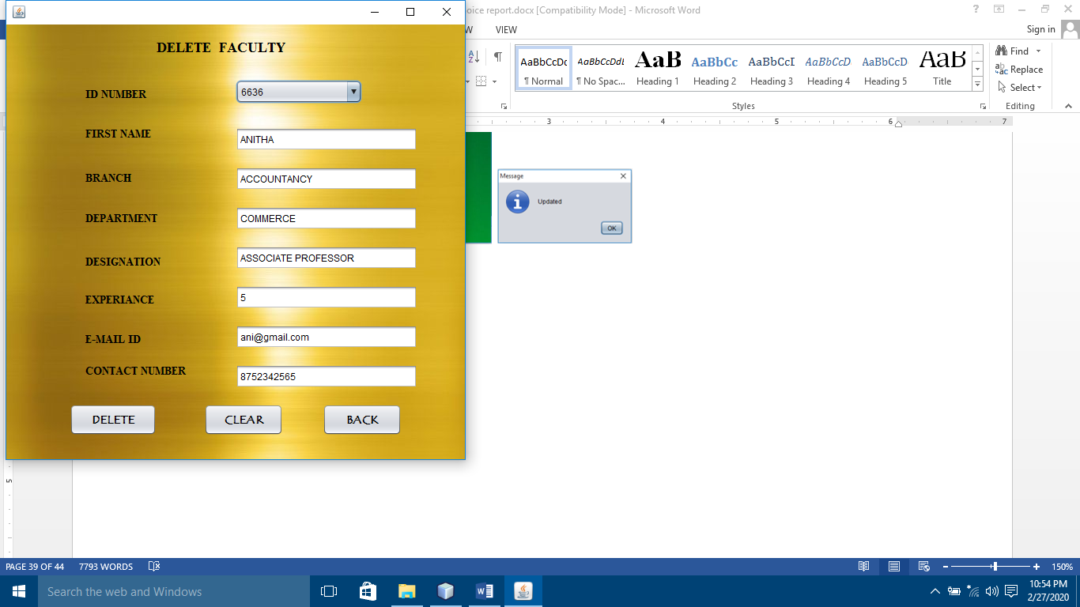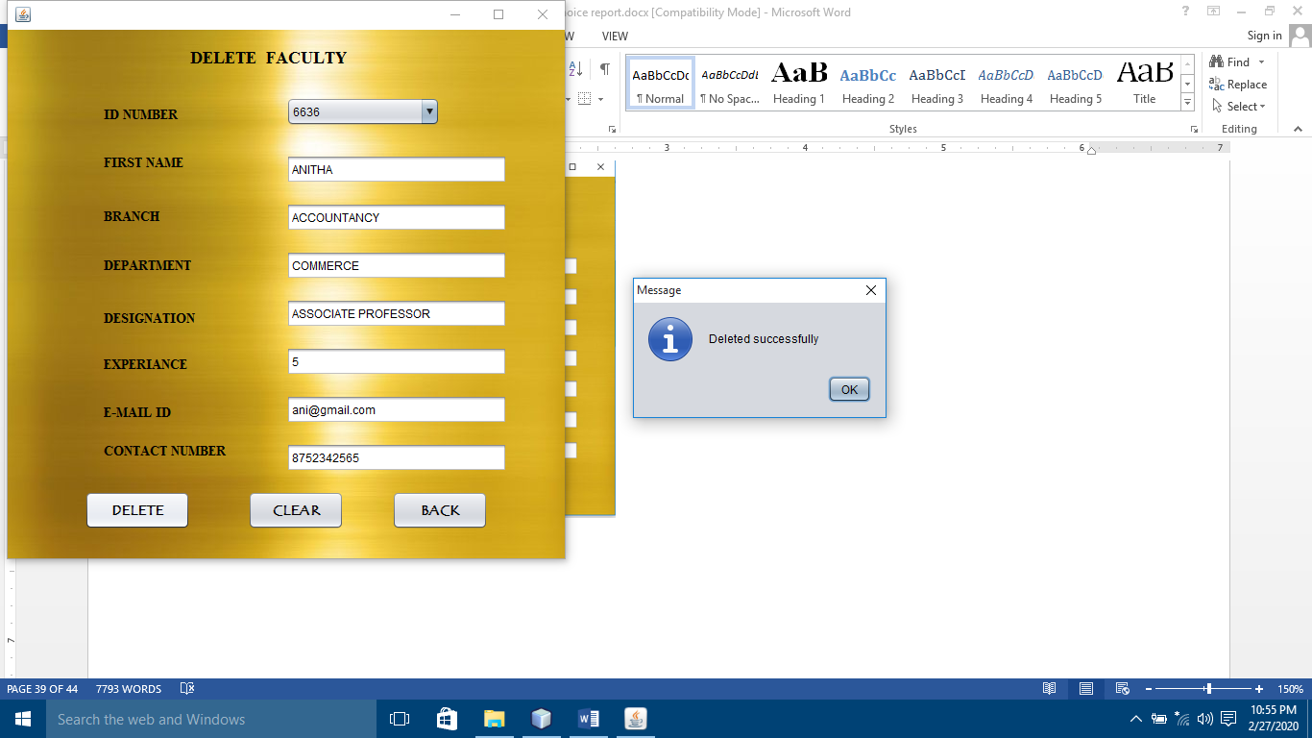

**ALL FACULTY PERFORMANCES:**

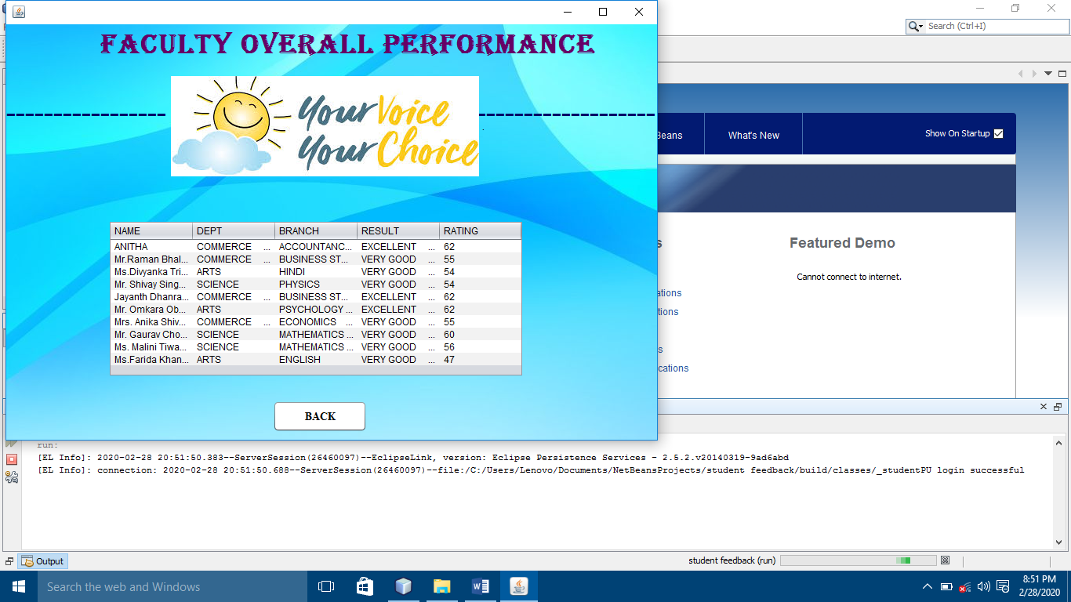

**CANTEEN PERFORMANCE:**

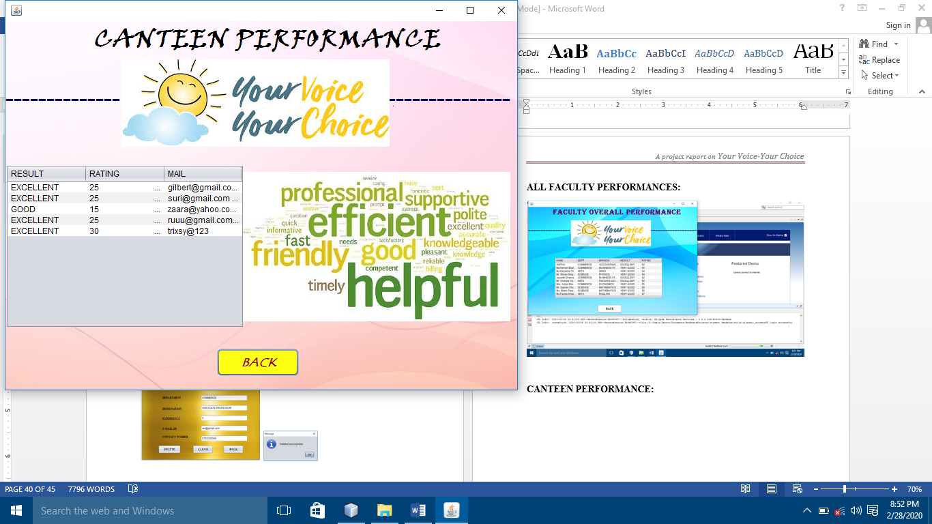

**EVENT PERFORMANCE:**

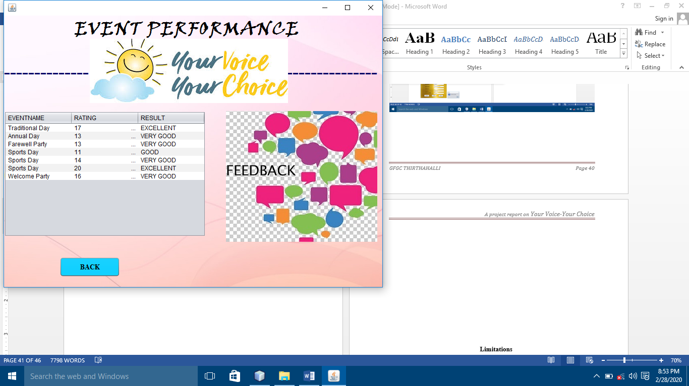

**LIBRARY PERFORMANCE:**

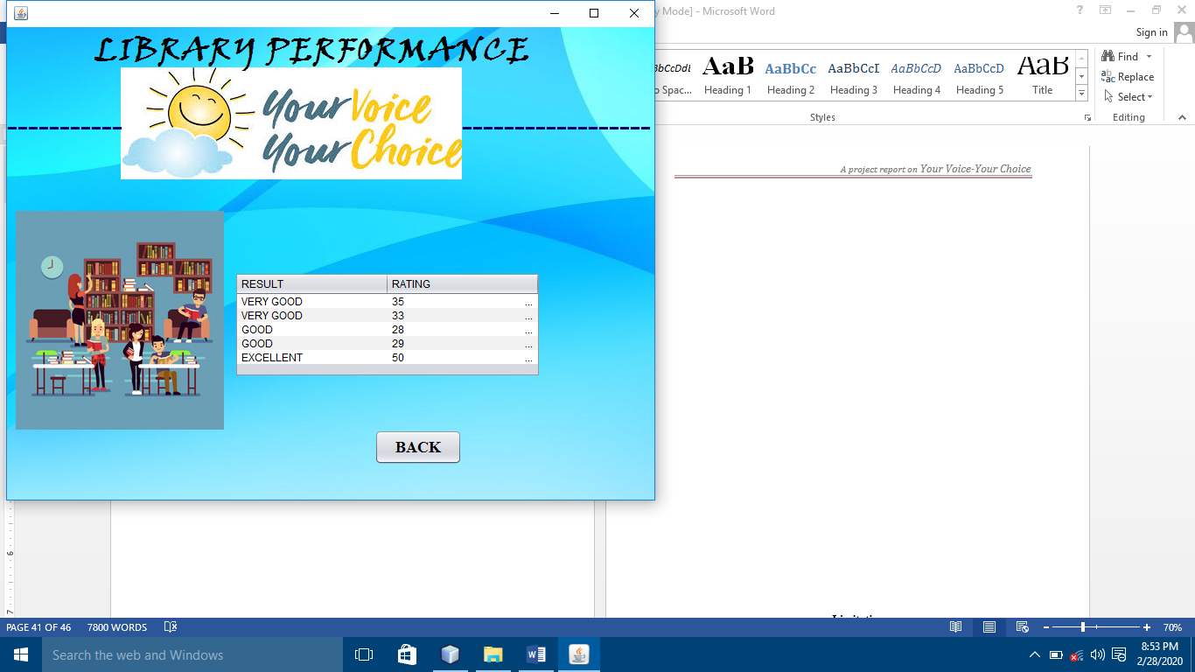

**NEW STAFF REGISTRATION:**

